**POWER ELECTRONICS LAB EXPERIMENT 5**

**Name: Ayush Pandit**

**Roll No: 19EE10067**

**PART - A**

**Triggering Circuit:**

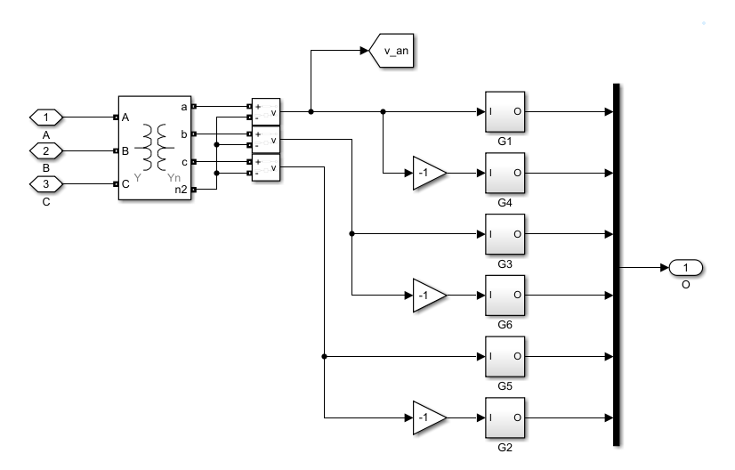

**G1:**

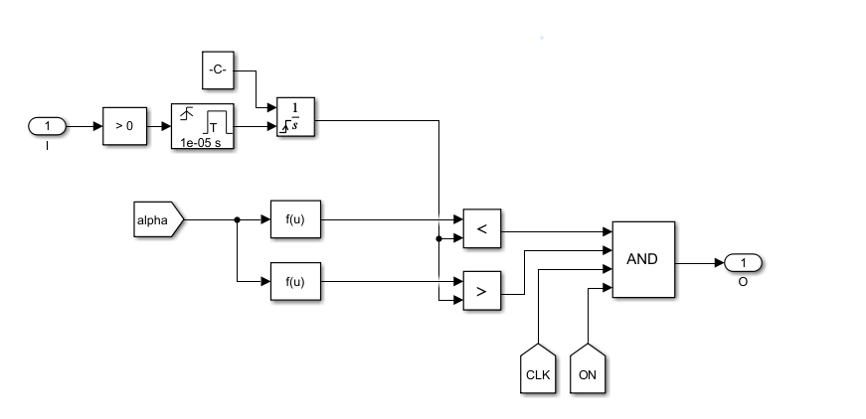

**PART - B**

**Circuit Diagram:**

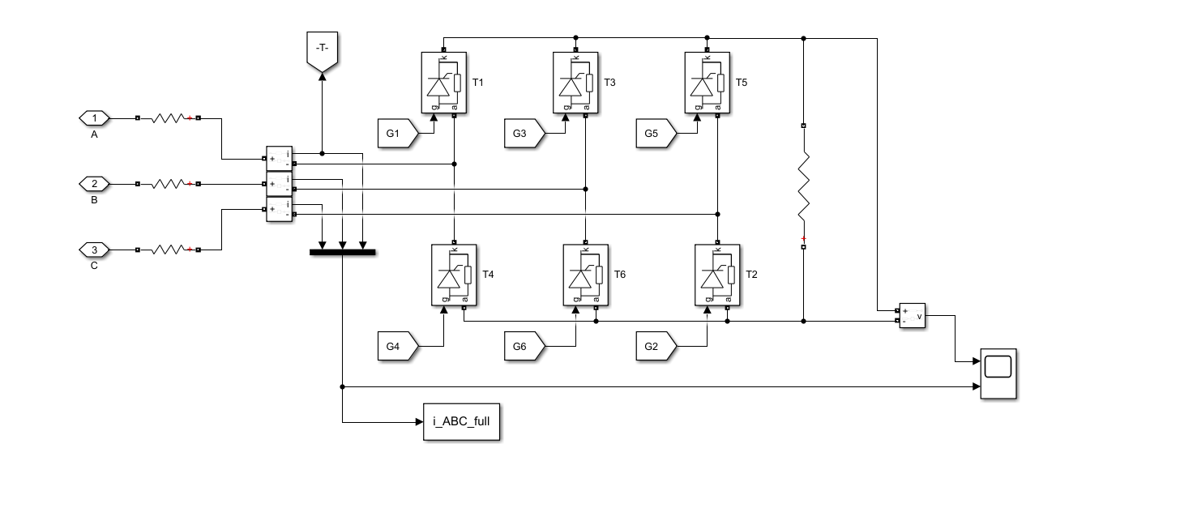

**1.**

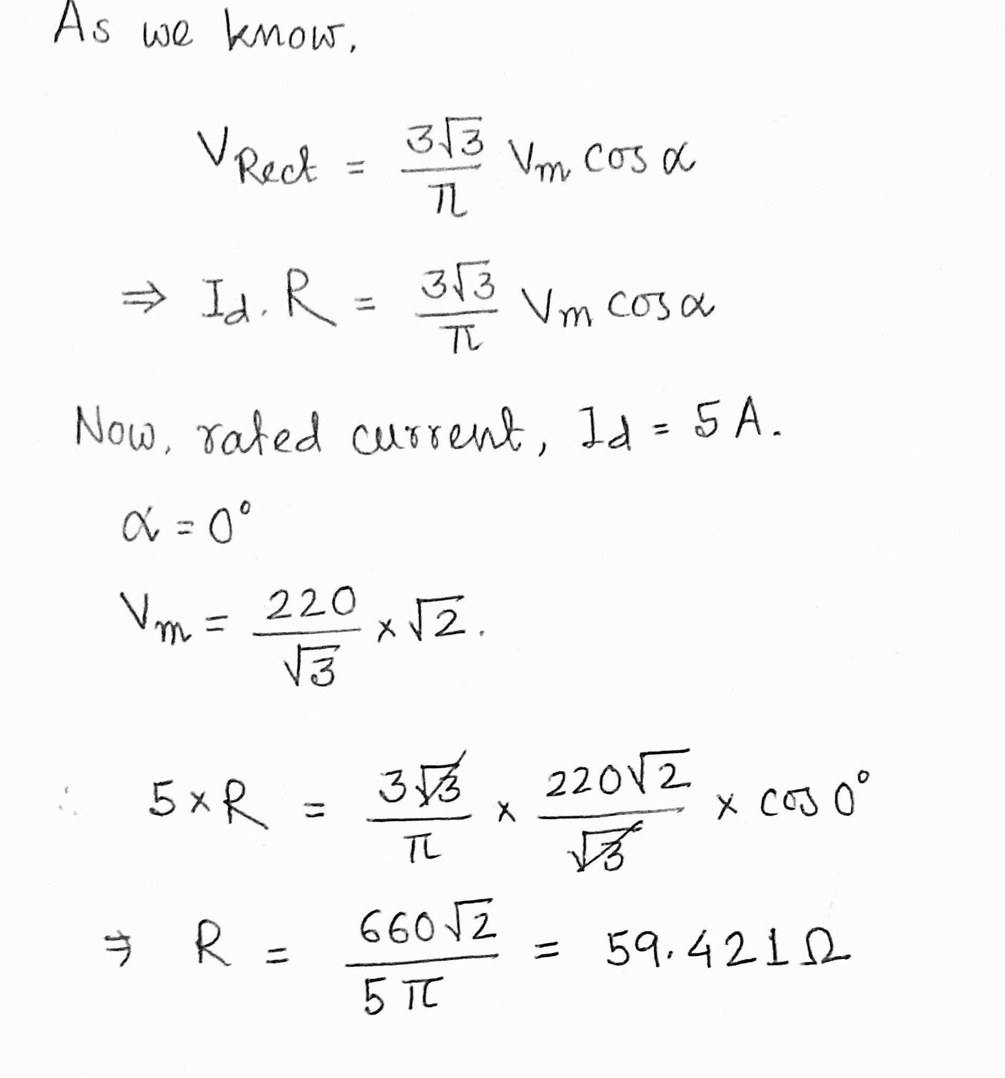

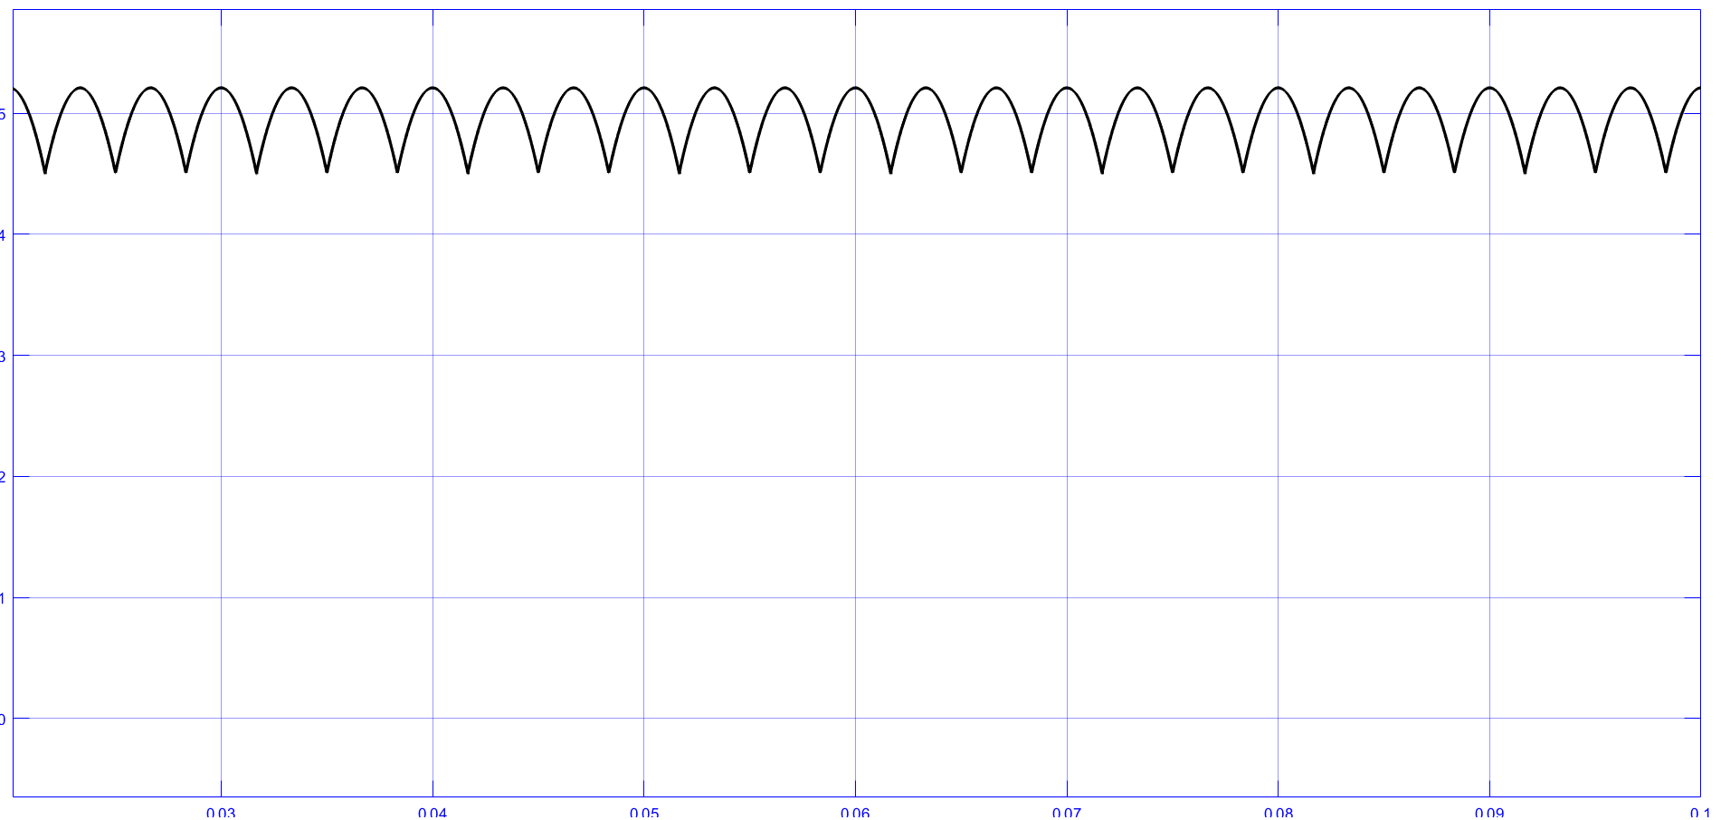

Average load current = 4.972 A

**2.**

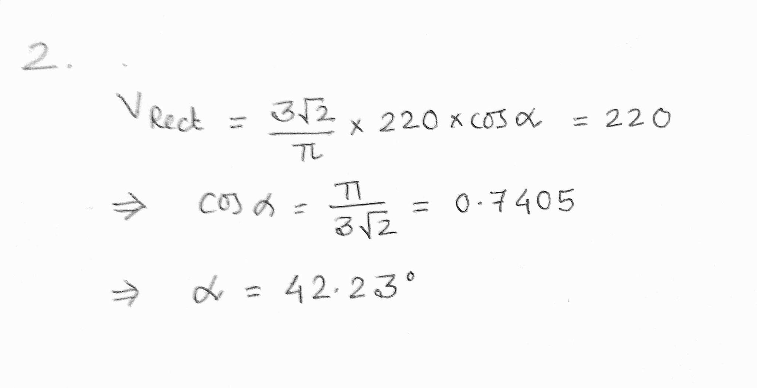

**3.**

**Output Voltage:**

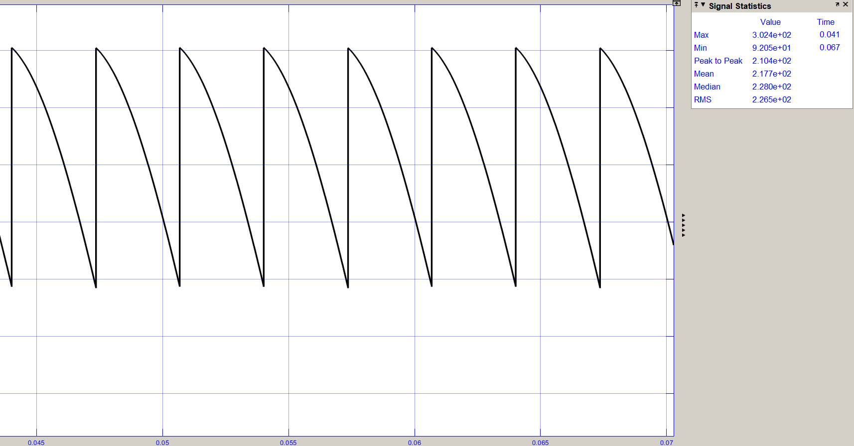

Average output voltage = 217.7 V

**AC side currents:**

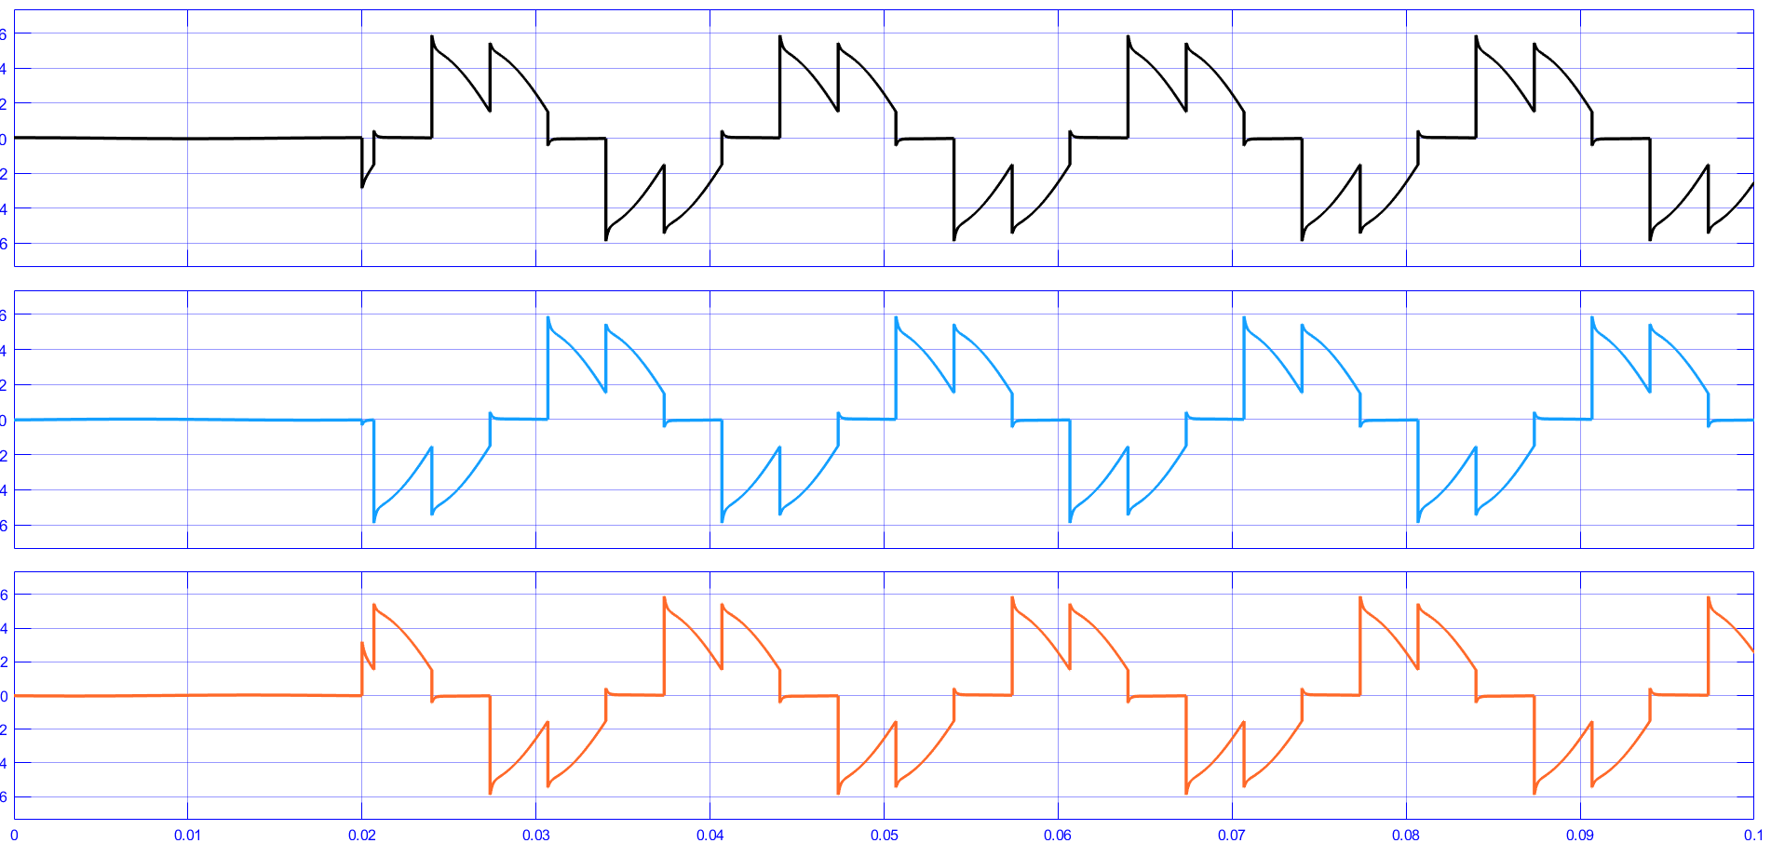

**4.**

**R = 59.421 Ω**

| **Alpha (degree)** | **Average output Voltage**  **(V)** | **AC side current (RMS)**  **(A)** |
| --- | --- | --- |
| 0 | 295.6 | 4.064 |
| 15 | 285.1 | 3.934 |
| 30 | 255.3 | 3.567 |
| 45 | 208.6 | 2.996 |
| 60 | 146.5 | 2.303 |
| 75 | 87.29 | 1.565 |
| 90 | 39.16 | 0.868 |

**5.** 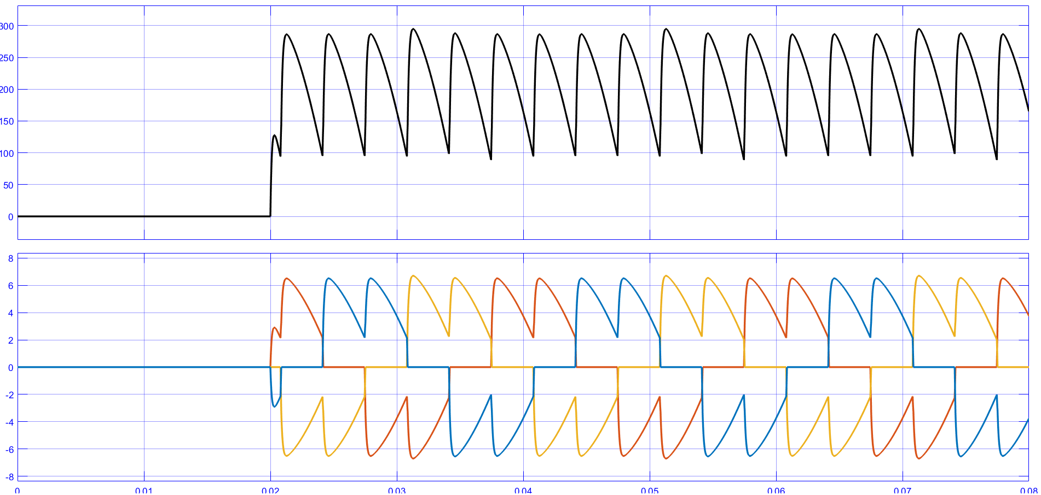

**PART - C**

**Circuit Diagram:**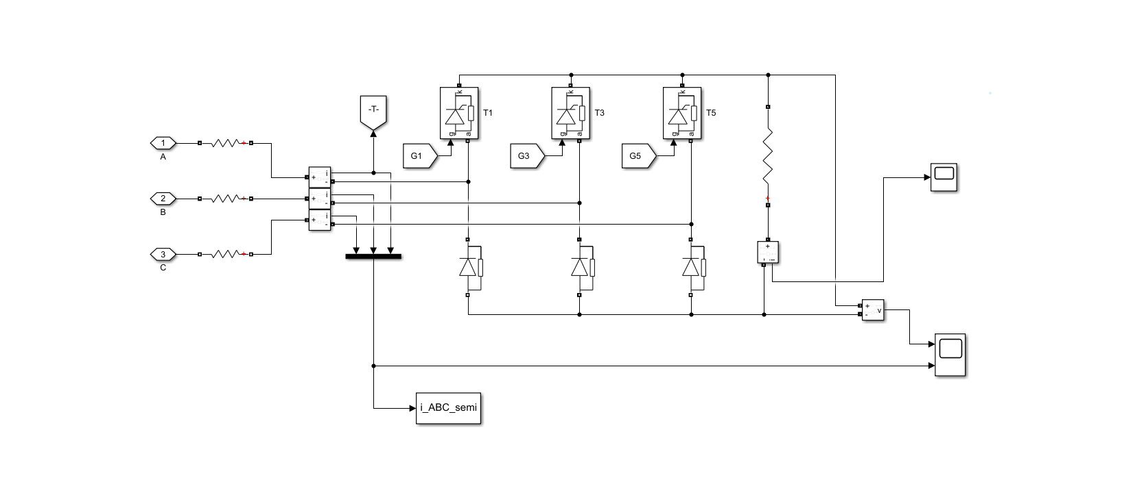

**1.**

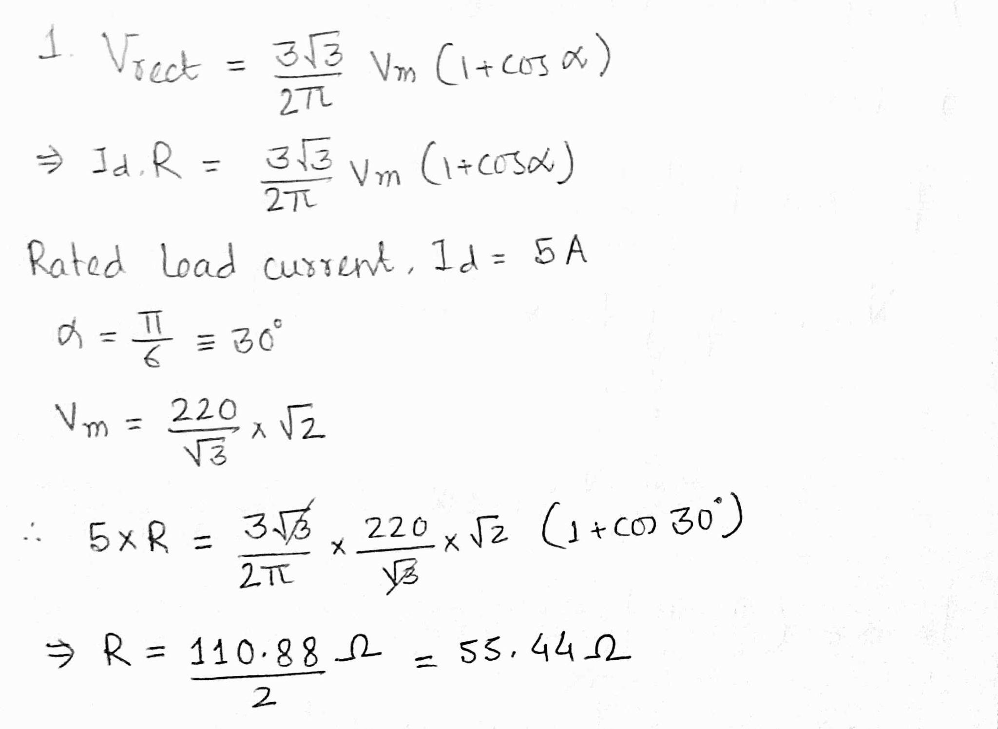

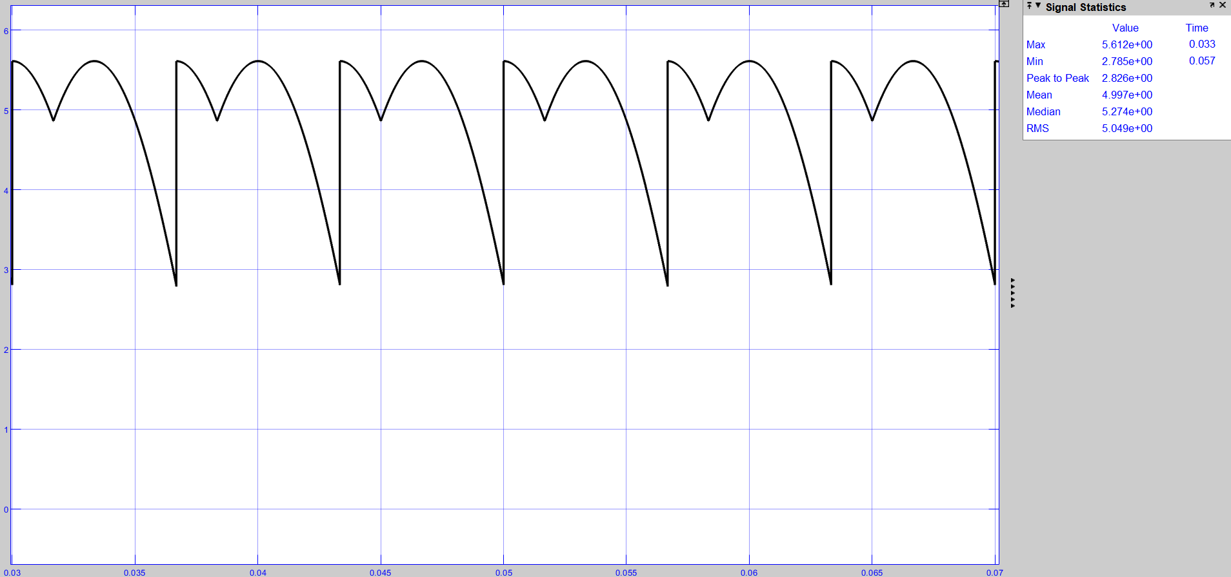

Average Load current = 4.997 A

**2.**

**Load current at alpha = 59°**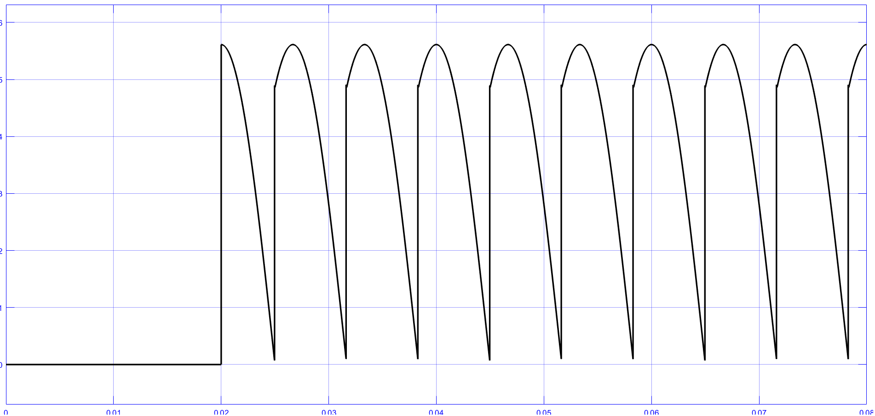

**Load current at alpha = 60°**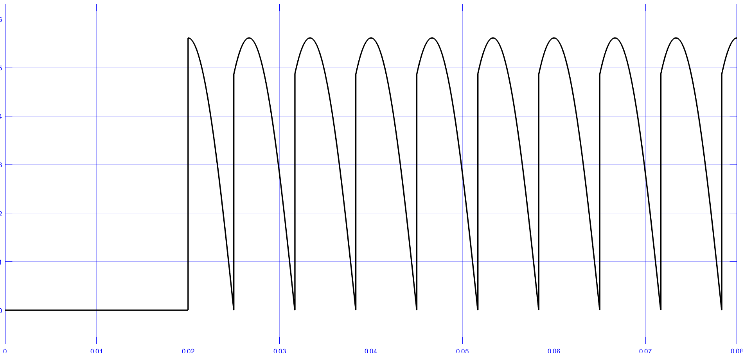

**Load current at alpha = 61°**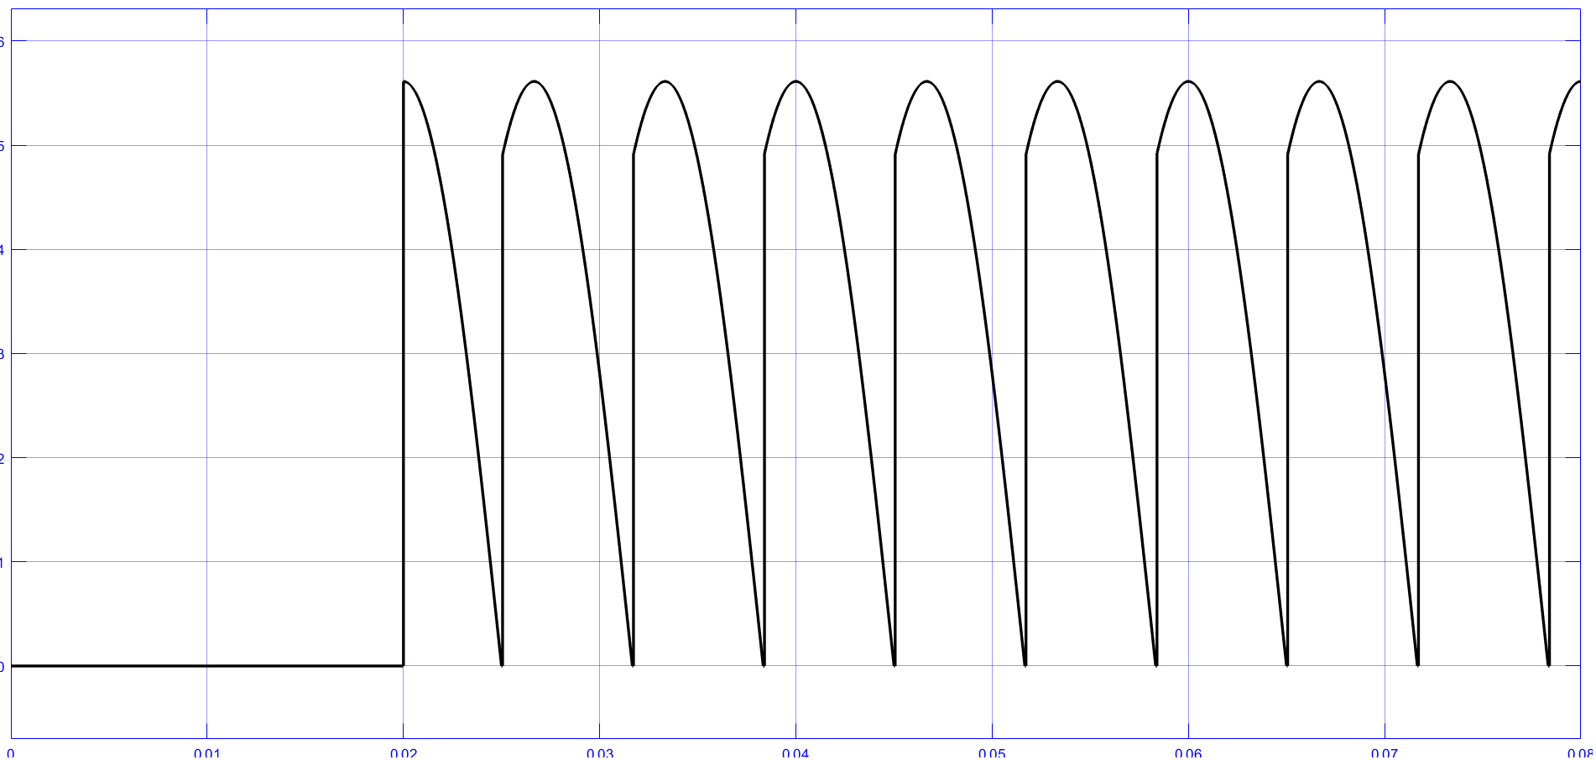

**Hence**, the load current becomes discontinuous as soon as it crosses alpha = **60°**

**3.**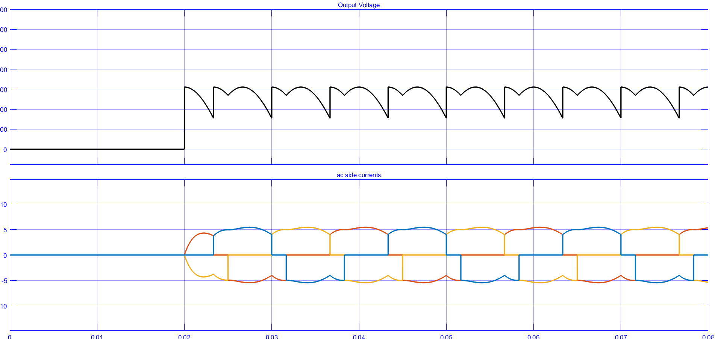

Average output voltage = 277.1 V

**4.**

**R = 55.44 Ω**

| **Alpha (degree)** | **Average output Voltage**  **(V)** | **AC side current (RMS)**  **(A)** |
| --- | --- | --- |
| 0 | 297.1 | 4.314 |
| 15 | 291.9 | 4.225 |
| 30 | 277.1 | 4.006 |
| 45 | 253.3 | 3.679 |
| 60 | 222.8 | 3.280 |
| 75 | 185.5 | 2.862 |
| 90 | 148.1 | 2.417 |

**PART - D**

| **Parameter** | **Full-controlled Converter** | **Semi-controlled Converter** |
| --- | --- | --- |
| AC side currents (RMS) | 4.068 | 4.072 |
| Fundamental component of the AC side currents (RMS) | 3.892 | 3.861 |
| THD (in %) of the AC side currents | 31.1% | 34.1% |
| Input power factor | 0.922 | 0.914 |
| Fundamental active power (W) | 2025.5 | 2009.4 |
| Fundamental reactive power (VAr) | 542.74 | 538.42 |

**Discussion Questions:**

**1. Consider an ideal three-phase full-controlled converter with an R load. Obtain the expression of the average output voltage (for α ∈ [0, π/2]).**

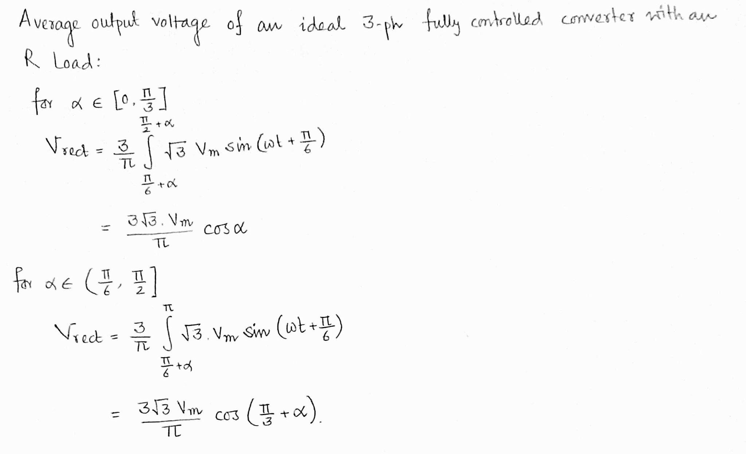

**2. Refer to Part B(5), what is the commutation overlap angle µ? What is the average output DC voltage?**

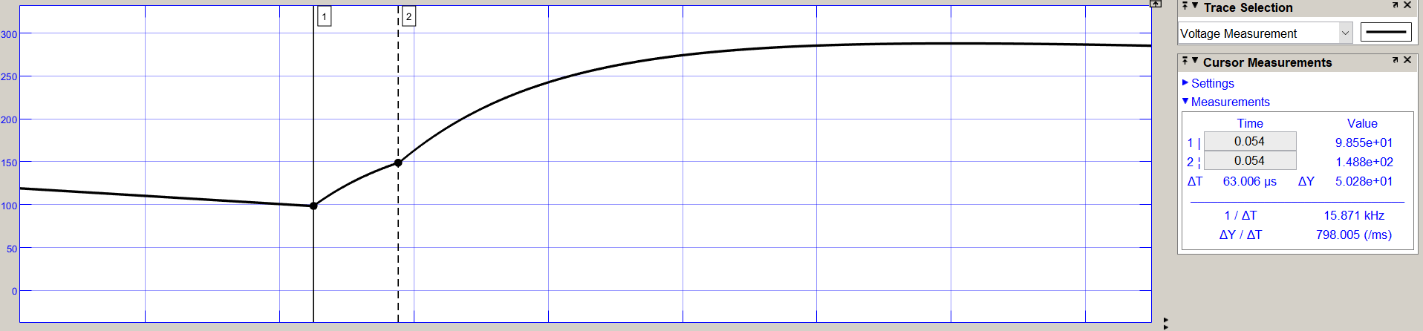

ΔT = 63.006 μs

Hence, commutation overlap angle = (63.006μ / 3.330m) x 180**°** = 3.406**°**

Average DC voltage = 212.1 V

**3. Refer to Part D, compare the distortion factor of the two converters. Why is the distortion factor less in the case of the semi-controlled rectifier?**

Distortion factor of three-phase fully controlled AC to DC converter = I1/I = (3/π) = 0.955

Distortion factor of three-phase semi-controlled AC to DC converter = I1/I = √(6/π(π-α)) x cos(α/2)= 0.807 for α = π/12.

For a semi-controlled rectifier, the diodes allow more number of harmonics in the output. That is why the distortion factor is less for semi-controlled AC to DC converter.